|  |
| --- |
|  |
| EZ White Label Sign Up |
| Tech Specification |
|  |
| **J. Todd Jennings** |
| **10/1/2021** |

Table of Contents

1. Branding 3

1.1. Branding Guide - Colors 3

2. Fonts 3

2.1. Renogare 3

2.2. Bilo-Light 3

3. Pages 3

3.1. Page Tree 3

3.2. Login - Main Page 4

3.2.1. User Interface 4

3.2.2. Widget Table 4

3.3. Create Account 5

3.3.1. User Interface 5

3.3.2. Widget Table 5

3.4. Payment Page 7

3.4.1. User Interface 7

3.4.2. Widget Table 7

3.5. Welcome Page 9

3.5.1. User Interface 9

3.5.2. Widget Table 9

1. Branding
   1. Branding Guide - Colors

1. Fonts
   1. Renogare
   2. Bilo-Light
2. Pages
   1. Page Tree

Login - Main Page  
Create Account  
Payment Page  
Welcome Page

* 1. Login - Main Page

Site should default to Login Page

* + 1. User Interface

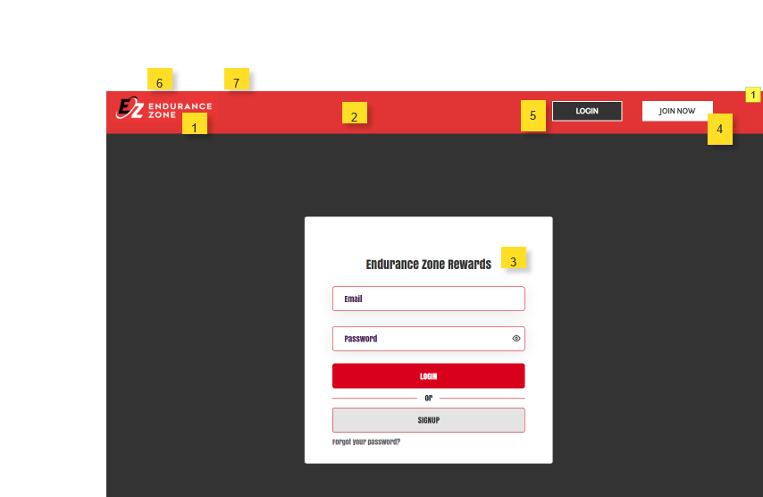

* + 1. Widget Table

|  |  |
| --- | --- |
| Note number | Note |
| 1 | Logo is dynamically pulled from partner profile data based on the URL. So we would grab the base URL (example http://rewards.spartan.com) query the partner table for the partner whos (RewardURL) matches. |
| 2 | The header color would be pulle from the Partners (Reward Primary Color) |
| 3 | Dynamically pull the Partner Name |
| 4 | Links to Sign Up Form |
| 5 | Links to Login Page |
| 6 | Fav Icon |
| 7 | Partner Name in Browser Title Bar |

* 1. Create Account

All fields are required except coupon and affiliate

* + 1. User Interface

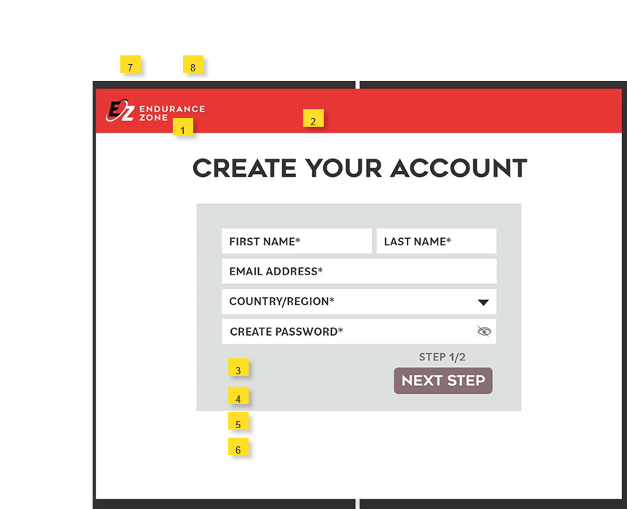

* + 1. Widget Table

|  |  |
| --- | --- |
| Note number | Note |
| 1 | Logo is dynamically pulled from partner profile data based on the URL. So we would grab the base URL (example http://rewards.spartan.com) query the partner table for the partner whos (RewardURL) matches. |
| 2 | The header color would be pulle from the Partners (Reward Primary Color) |
| 3 | Add Coupon Code - This will reference a coupon code in the Rewards Database that will have a start and end date. If code is entered need to confirm it is active based on the date range. The coupon code will be a discount amount (exampel 40%) off. As such once the user moves to the next screen for payment information. The main displayed price should show an adjusted price based on the discount amount |
| 4 | This should be a text field (Affiliate ID). This should ONLY be displayed for the URL that matches Endurance Zone. This field would capture within the URL the passed in parameter (afid) example - https://rewards.endurancezone.com?afid=11142 |
| 5 | This should be a check box for the - I agree to the Terms & Conditions and Privacy Policy * (required) field |
| 6 | This should be a checkbox and ONLY visible if the URL is Endurance Zone -Text would be- I would like to hear about new exclusive discounts, exciting brand promotions and competitions |
| 7 | Fav Icon |
| 8 | Partner Name in Browser Title Bar |

* 1. Payment Page

The partner sign up pricing amount and currency type is pulled from the Partner Profile attributes. As well the integration to Stripe will pull the Stripe API Keys from the Partner Profile  
  
After submitting the sign-up payment information. Upon successful payment capture the member information is sent to the EZ Rewards API referenced later in this document. Then the user is redirected to the “Welcome Page” in step 3.

If the payment is not successful display status error message in red below the ‘create your account’ heading.

* + 1. User Interface

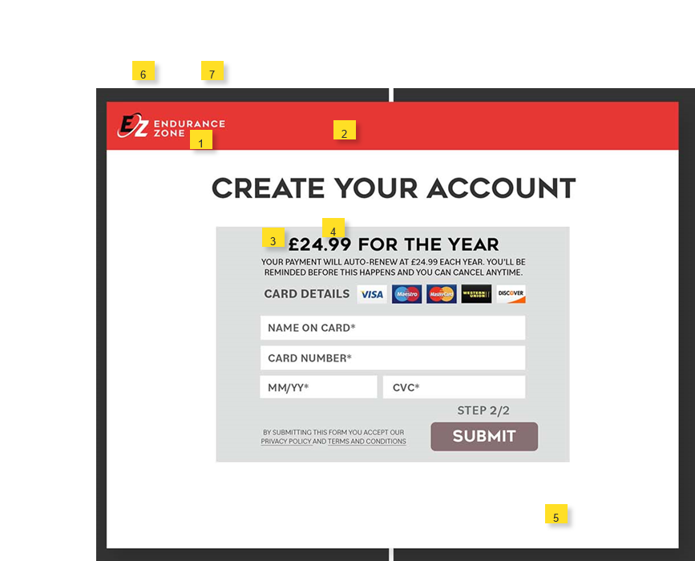

* + 1. Widget Table

|  |  |
| --- | --- |
| Note number | Note |
| 1 | Logo is dynamically pulled from partner profile data based on the URL. So we would grab the base URL (example http://rewards.spartan.com) query the partner table for the partner whos (RewardURL) matches. |
| 2 | The header color would be pulle from the Partners (Reward Primary Color) |
| 3 | Currency type (symbol) is pulled from the Partner Profile |
| 4 | The sign-up amount is pulled from the Partner Profile (MemberRetailPrice) |
| 5 | Stripe API keys will be pulled from the Partner Profile |
| 6 | Fav Icon |
| 7 | Partner Name in Browser Title Bar |

* 1. Welcome Page

After successful payment capture user is redirected to Welcome page. Welcome to “PARTNER NAME” REWARDS. The “Partner Name” is dynamic (D). The social media icons should be displayed provided there are values within the Partner Profile for each. If there is no value do not display image.

View Rewards button would redirect user to the Partners Login URL

* + 1. User Interface

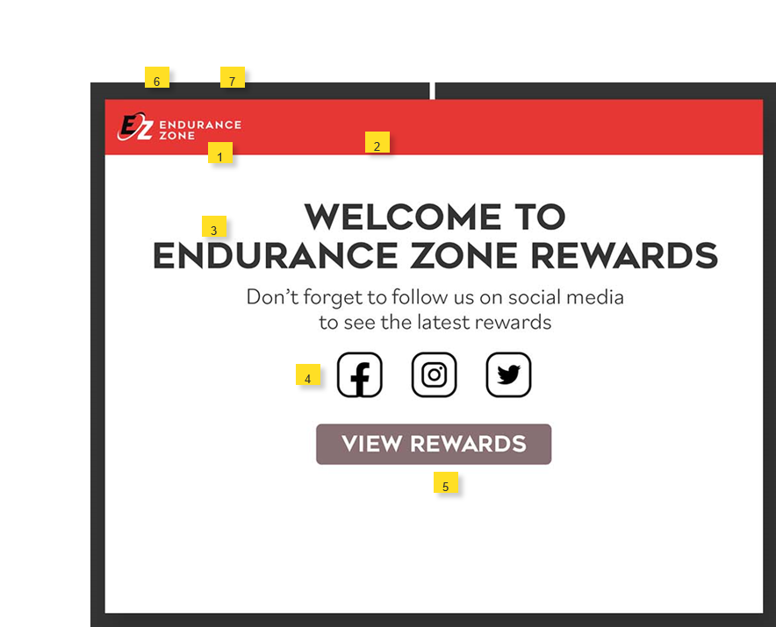

* + 1. Widget Table

|  |  |
| --- | --- |
| Note number | Note |
| 1 | Logo is dynamically pulled from partner profile data based on the URL. So we would grab the base URL (example http://rewards.spartan.com) query the partner table for the partner whos (RewardURL) matches. |
| 2 | The header color would be pulle from the Partners (Reward Primary Color) |
| 3 | Welcome to "Partner Name" should be pulled from Partner Profile |
| 4 | Social Media icons displayed if within the Partner Profile they have a corresponding URL value |
| 5 | Button links to the Partners Login Page |
| 6 | Fav Icon |
| 7 | Partner Name in Browser Title Bar |